ELEVATED LEVELS OF HEAVY METALS DETECTED IN MODERN SOILS AND FLOODED-CAVE SEDIMENT FROM

THE BAHAMAS

Stephanie J. Schwabe^{1, 2}, Eric M. Cathcart¹, and James L. Carew³

¹University of San Diego, Marine Science and Environmental Studies, MARS,
5998 Alcala Park, San Diego, CA 92110-2492
²Rob Palmer Blue Holes Foundation, 5 Longitude Lane, Charleston, SC., 29401
³College of Charleston, Department of Geology and Environmental Geosciences, 66
George Street, Charleston, SC. 29424

ABSTRACT

Red to reddish-brown soils, collected on San Salvador Island and Rum Cay, and from within submerged caves on Grand Bahama and Andros islands were analyzed, using the EPA Total Metals 6000/7000 Series method to determine their heavy metals content. The soils and the cave sediment all contain many of the following metals: As, Ba, Be, Cr, Cd, Co, Cu, Mo, Pb, Ni, Sb, Se, TI, Ag, V, Zn, Hg. Similar analysis of lithified Bahamian limestone samples revealed no detectable concentrations of any of the metals cited above. XRD results show that the red clay collected from the phreatic zone in Lucayan Caverns on Grand Bahama Island is lepidocrocite, an orthorhombic, biaxial crystalline iron oxyhydroxide (FeO[OH]). The traditional qualitative explanation for the accumulation of the insoluble material in soils and paleosols on Bahamian islands was the concentration of insoluble residues left behind by limestone dissolution. However, considering the purity of Bahamian carbonate rocks, this would require improbable amounts of carbonate dissolution. Additional data obtained during recent analyses of paleosols, and a few soils from several Bahamian islands to determine their source, show that the concentrations of the heavy metals (such as V, Pb, As and Hg) detected in the modern deposits are significantly higher than the concentrations of those same metals in the paleosols. These data suggest that the heavy metal content seen in Bahamian soils and the cave sediment likely represents a long-range transport (LRT) signature. It is noteworthy that half of the modern soil samples analyzed exceed the EPA Preliminary Remediation Goals for residential soil in Florida and California, and those regulations would likely require the contaminated soils be removed or remediated prior to residential development.
Several earlier studies have indicated that Saharan dust is the most likely source of the non-carbonate components of Bahamian soils and paleosols. Our analyses confirm that likely source and indicate that this airborne material is also being transported into flooded caverns and caves. In addition, the elevated metals content (esp. V, Pb, and As) of the soils may indicate that some of the airborne material may be dust derived either from the Middle East via burning of coal and oil and / or from lead and zinc mining areas in Algeria. The V and possibly some of the As may be derived from volcanic events in the Caribbean.

INTRODUCTION

The non-carbonate material in the red to reddish-brown soils that can be found throughout the Bahamas and the Caribbean have been identified as material from the Sahara and Sahel desert (e.g., Muhs et al., 1990; Ersek et al., 2006). Interest in the long range transport (LRT) of dust over the planet has increased. Recently, it has been documented that dust particles now coming out of North Africa are carrying with them organic pollutants and an array of microbes that may be responsible for some of the diseases occurring on the reefs in the Caribbean (Wright, K., 2005; Garrison et al., 2006). The largest sources of dust to Earth’s atmosphere are the Sahara and Sahel regions of North Africa and the Gobi, Taklamakan, and Badain Juran deserts of Asia (Griffin and Kellogg, 2004; Evans et al., 2004). The current estimate for the quantity of arid soil that moves some distance in Earth’s atmosphere each year is 2 billion metric tons (Perkins, 2001; Garrison et al., 2006). Fifty to 75% of this quantity is believed to originate from the Sahara and Sahel (Moulin et al., 1997; Perry et al., 1997; Goudie and Middleton, 2001; Prospero and Lamb, 2003). North African dust incursions into the Caribbean and western Atlantic region occur on average about three times a year. The events occur twice during the summer and once during the spring time, with two events from the Sahara and one from the Sahel (Holmes and Miller, 2004; Chiapello et al., 1997).
This loose soil that has been collected on the surface of the Bahamian islands of San Salvador, Rum Cay, and North Andros, and in samples from currently submerged caves from Grand Bahama and South Andros (Figure 1), contain the following metals in detectable amounts (Sb, As, Ba, Be, Cr, Cd, Co, Cu, Mo, Pb, Ni, Sb, Se, TI, Ag, V, Zn, Hg). The exceptionally high levels of Pb, As, total Cr, and V found on Dixon Hill, San Salvador and Lucayan Caverns on Grand Bahama may confirm that the morphology of the surface of the island and the transport ability of the oceans may play a role in concentrating metals. Average concentrations of Pb in the Saharan transported dust (48 mg/kg) were significantly higher than in the fine fraction of the Saharan soils (24mg/kg) (Guieu et al., 2002). The As content of dust material collected in Mali, North Central Africa, was approximately 17 mg/kg. Arsenic in a cistern collected on the eastern-most end of St. John, U.S. Virgin Islands was 38 mg/kg and in Chassahowitzka, Florida, 79 mg/kg (Holmes and Miller, 2002; 2004).
Holmes and Miller (2002, 2004) found that As carried by dust was highest at the top of their cores, a discovery they attribute to increased desertification of the Sahel over the past few decades. On average, the African dust supplies about 25% of the As deposited from aerosols in the southeastern U.S. (Homes and Miller, 2004). In 2000, African dust that was examined in the Azores was enriched with Hg, and the origin was believed to be from open-pit mercury mines in Algeria. We recognize that these metals must have been transported in via the atmosphere, and we confirmed it with the analysis of the pure limestone, typical of the Bahama Islands, listed in Table 1. Many authors (e.g., Harrison and Anderson, 1919, Ahmad and Jones, 1969) argued that these metals were the accumulation of the impurities of the host rock; however, this is not likely because an unreasonable amount of the host rock would have to be dissolved. In one case (Birkeland, 1999, p. 199-200) it was suggested that an entire island would have to be dissolved to explain the observed soil concentrations seen today.
Analysis of a rock sample from San Salvador revealed that of the seventeen metals screened for, only seven were detected, and they were in quantities just above the minimum detectible limits (Table 1). The heavy metals, along with bacteria and organic and inorganic pollutants adsorbed onto aeolian particles, transported by wind to distant landmasses is the only reasonable explanation for their occurrence in the Bahamas. Other researchers have emphasized the importance of LRT dust to the genesis of soils on limestone islands in the Caribbean and the western Atlantic Oceans. Foos (1991) and Carew and Mylroie (1991) suggested an African dust origin for the soil in the Bahamas, and Muhs et al. (2007) suggest that the soils in the Bahamas and other regions are derived from African dust and/or Mississippi loess. However in their study the majority of data concerning the Bahamas was limited to Nassau, an island afflicted with heavy pollution and overpopulation, and two Cays within the Exuma Islands (Muhs et al., 2007). This is of importance because based on Table 1, these data suggest that the distribution of the foreign dust throughout the islands of the Bahamas and on the island themselves may not be equal.

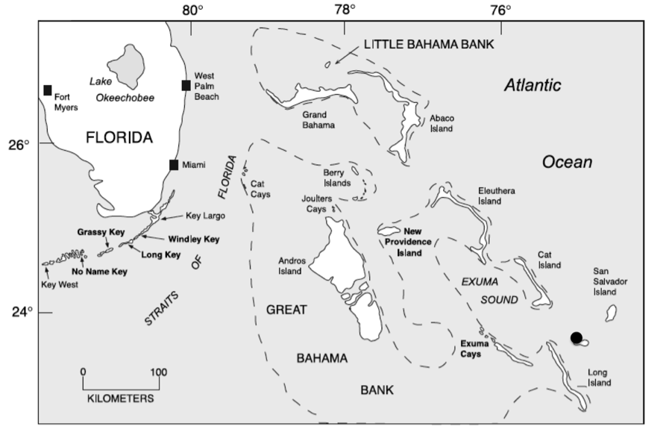
Figure 1. Map showing the Bahama Islands. Samples were collected on San Salvador, Rum Cay (black dot), east end Grand Bahama, and South Andros.

In this present study, we are collecting soil samples from across the Bahama Archipelago to determine what the distribution of metals is both on the surface of the islands as well as what has accumulated in flooded caves in the Bahamas. Prevailing winds, surface topography, and marine currents that transport the dust into submerged caves are believed to play a role in the varying concentrations of metals we observe. Here we present a comparison of new data from several islands in the Bahamas and data from earlier studies in the Bahamas and from St. Johns in the U.S. Virgin Islands.

METHODS

Surface samples were collected using a metal spatula, to prevent contamination, to scrape the soil sample into labelled Nalgene bottles or clean sample bags. Underwater sediment samples were collected using a 30.48 cm long prospectus tube (Figure 2), with bung placed on both ends to secure the sample. Water column samples were collected using multiple fills of sterile 30 ml syringes and then dispensed into 500 ml Nalgene bottles containing 2 ml of HNO₃. Analysis of aqueous samples was done using the EPA method 3010A and the method 3050b for acid digestion of sediments, sludge, and soils. These methods can be found at http://www.epa.gov/epawaste/hazard/testmethods/sw846/online/3_series.htm

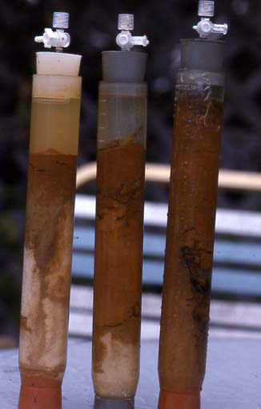
Figure 2. Prospectus corers used to collect sediment containing Saharan dust in underwater environments. The three-way stopcocks were set to open to allow water that came in during insertion of the core to escape. The stopcock was closed prior to removal of the core to generate suction.

RESULTS

The samples, both on the surface and from below sea level, are for the most part heavily tainted with metals not native to the local rocks. San Salvador limestone (LS) (Table 1, line 2) results show only trace amounts of these metals. Of the thirteen samples collected, minus the dog stool, all but four samples contain As at levels that exceed EPA Preliminary Remediation Goals for soil in California at both residential and industrial sites. Eight of the thirteen samples exceed Florida residential soil levels but only four of the thirteen exceed Florida industrial levels. Lead levels only exceed California residential soil levels, whereas the lead levels fall below minimum acceptable amounts according to Florida residential and industrial standards. Total Cr and V are the only other two metals that are high when compared to California and Florida residential limits.
The very high Hg levels within the dog stool are not comparable to the soil samples from the same area. The dog stool represents what might be considered bioaccumulation; however, because of the low levels of Hg detected within the soils, it is most likely inhalation of Hg vapour is responsible for the high Hg content in the stool.

Table 1.
Heavy metal results from Grand Bahama, San Salvador, and Andros Island Bahamas.
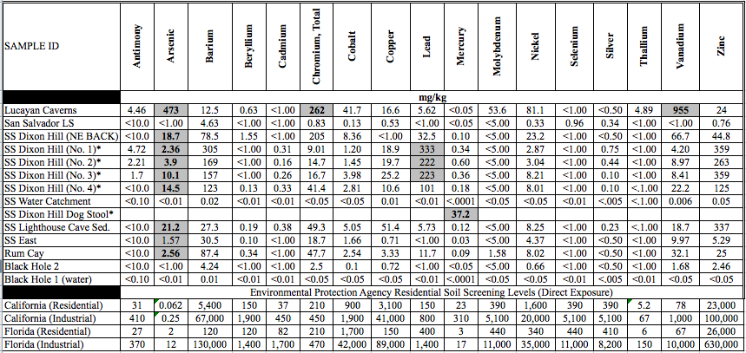

SS Dixon hill* These samples were collected starting at the base of the lighthouse to the parking lot located next to the lighthouse. Sample 1 is at the base, 2 is ~3 metres out, 3, 6 metres out and 4 is the parking lot, about 10 metres out from the base of the lighthouse.
Bold results indicate exceedence of Florida Residential screening levels
Gray infill indicated exceedence of California residential screening levels
Florida soil screening levels: Technical report: Development of cleanup target levels for Chapter 62-777, F.A.C.,
Centre for Environmental & Human Toxicology, University of Florida, Gainsville, Florida, February 2005
California Soil Screening levels: US EPA, Region 9, preliminary Remediation Goals, 2004

DISCUSSION

LRT of Saharan dust, and potentially volcanic dust from the Caribbean, is the most likely source of non-carbonate material of the soils found throughout the Bahamas. Based on the analytical results of the relatively pure local limestone sample (Table 1), the trace amounts of metals that were detected are most likely metals that had filtered into the pores of the local rock and are not actually a part of the fabric of the limestone. Regardless, the trace amounts of metals found within the local limestone could not account for the large concentrations of metals that we have detected in the soils and cave sediment samples. The amount of red dust varies among locales on the islands where collection was done. The red soil is commonly just 1 -2 cm thick, often in small pockets between the rocks or under vegetation. Dry caves also commonly contain moist or dry red dust soil.
The red clayey sediment found within flooded caves on Grand Bahama, specifically Lucayan Caverns and Mermaid’s Lair/ Owl’s Hole (Figure 3), are the largest known accumulation of red clayey material found to date in the Bahamas (Figure 4). In some areas, the clay is over a meter thick. The question as to why there is so much of this iron-oxide on the cave floor may be because, just like the floor of the Atlantic Ocean, the caves represent long-term repositories for dust that filter down from the island surface as well as introduction via input from the ocean due to tidal flow in the caves. These quiescent water environments become the perfect setting for the deposition of very fine dust particles.

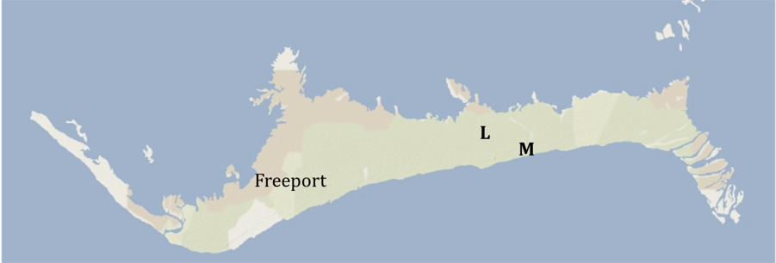
Figure 3. Map of Grand Bahama Island. “L” indicates the location of Lucayan Caverns and “M” is for Mermaid’s Lair.

XRD results from samples collected in flooded horizontal caves identified the red clay as lepidocrocite, an orthorhombic, biaxial crystalline iron oxyhydroxide. The analytical results using the EPA method 3010A and the method 3050b for acid digestion on the same samples, brought to our attention the strikingly high levels of As, Cr and V.
Naturally occurring As is commonly found in volcanic glass in volcanic rocks of silicic-rhyolitic or intermediate composition; adsorbed to and coprecipitated with metal oxides, especially iron-oxides and to sulphide minerals and organic compounds (Welch et al., 1988). Arsenic is present in more than 200 minerals, the most common of which is arsenopyrite, iron arsenic sulphide (FeAsS). Arsenic can be introduced into the groundwater either through natural or anthropogenic sources. Because industrial activity tends to be localized in the Bahamas, specifically on the west end of Grand Bahama, it would be difficult to explain regional patterns of distribution of As occurrence from industrial activity alone. It is our interpretation that the As is arriving adsorbed to the iron-oxide dust coming in from North Africa.
Arsenic is a redox-sensitive element meaning that it may gain or lose electrons in redox reactions (Hinkle and Polette, 1999). As a result, As can be found in various states in the environment (Masscheleyn et al., 1991). In water environments, arsenate,
(H₂AsO₄ – ) or (HAsO₄ ²⁻), [As V] is present as the negatively charged oxyanions. It adsorbs strongly to iron-oxide surfaces in acidic and near neutral pH water (Dzombak and Morel, 1990; Waychunas et al., 1993). Arsenite (H₃AsO3⁰), [As III], an uncharged species (Hem, 1985) is predominant when the environment is reducing. Adsorption and desorption reactions between arsenate and iron-oxide surfaces are particularly important in controlling mobility of the As because iron oxides are wide-spread in the hydrogeological environments. The iron-oxide deposits are settled well within the marine water environment in these caves and should potentially not pose a problem to the fresh water supply sitting on top of the marine water.

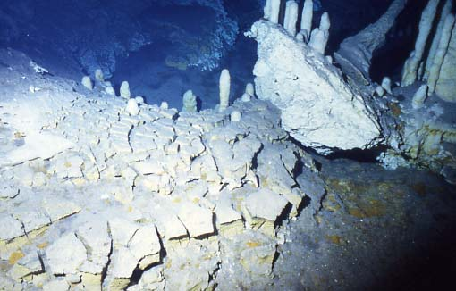
Figure 3. Red clay deposits on the floor of a passage in Lucayan Caverns, Grand Bahama Island.

Any potential of As making its way into the fresh water supply would have to come from above with meteoric input. However, if the As associated with the iron-oxide deposit is mobile, diffusion upward into the fresh water supply could pose a problem.
Based on the geochemical environmental conditions required for adsorption and desorption, a condition that could dictate whether a compound is mobile or not, measurements of these parameters where the clay was collected suggests that the environment at the top layers of the iron mud accumulation is microaerophilic and slightly acidic (Schwabe, 1999). The water column pH at the surface of the iron deposit is 6.94 and dissolved oxygen is 98% depleted. The pH value favours adsorption of arsenate to the iron-oxide, however deeper into the deposit, the condition may be the reverse. Arsenite may be the favoured species. Arsenite, according to the USEPA is 50 times more toxic to biological life then arsenate.
The two other metalloids that are represented in significant amounts associated with the iron-oxide are molybdenum and vanadium. Arsenic adsorption can be affected by the presence of other competing ions of which Mo and V are two of several known species (Higston et al., 1971; Livesey et al., 1981; Manning and Goldberg, 1996). The reason for this competition is that such compounds have similar geochemical behaviour and as such, compete for sorption sites. Phosphate is also such a compound (Robertson, 1989) but phosphate has never been detected within the water column of these caves; most likely because organisms use it up quickly. So the possible explanation for the high As and V may be an adsorption issue and not necessarily an issue of volume of dust. On average, As levels of sands collected in the Sahara is 17 mg/kg (Holmes and Miller, 2002; 2004). It is likely that the dust, in its travels from North Africa to its resting place within cave environments in the Bahamas, has passed through a variety of geochemical environments which would result in As adsorption in low pH environments and desorption in alkaline environments (i.e., the open oceans) multiple times before settling out within the cave environment itself. These environmental opportunities would certainly allow for As to become more concentrated in certain deposits, depending on speciation and again, depending on competition for sorption sites. It is also important that the surface area of the iron-oxide be extensive, so non-crystalline oxides are favoured (Hinkle and Polette, 1999). In addition, it appears that Cr (Table 1) may be another one of those geochemically similar compounds competing for sorption sites on iron-oxides (if we are to follow the argument that high concentration of other metals in association with iron-oxides deposits are competing and claiming sorption sites).
Recent research on the source of As within Floridian waters has promoted the idea that iron oxide in the subsurface would not be a likely occurrence and that the source of the As is the result of the oxidation of pyrite (Price and Pichler, 2002). Florida’s subsurface is inundated with extensive cave systems, similar to the Bahamas. As we have documented, dust from North Africa and the Sahel does, in large amounts, makes its way successfully into the subsurface, especially in flooded caves, and can impact the concentrations of As in the water. It is likely that any accumulation of fine dust, finer then the black, particulate organic material (POM) from decaying leaves found on the floors in the front parts of the caves in Florida, the finer Saharan dust would more likely be observed deeper into the caves systems where water flow decreases in some places exponentially providing a quite enough environment for ultra fine dust to accumulate.
The lead levels in surficial dust appears to be similar to that in both dry caves and flooded caves in the Bahamas (Table 1) and St. John U.S.V.I. (Table 2). The only area that appears to be more contaminated with Pb, is the top of Dixon Hill, which stands 50.3 m high on the Island of San Salvador.
Saharan dust, according to a chemical characterization (Guiev et al., 2002) contains 24 ± 9 mg/kg Pb. This is significantly less then the amounts measured from dust samples collected from the top of Dixon Hill on San Salvador. Lead will be retained in the upper 2-5 cm of soil, especially soils with at least 5% organic matter or a pH 5 or above (Guiev et al., 2002). It is effectively removed from the water column to the sediment by adsorption to organic matter and clay minerals, precipitation as insoluble salt, and reaction with hydrous iron and manganese oxide; however, under most circumstances, adsorption predominates (McKenzie, 1980). Although soils are immature and sparse throughout the Bahamas, the small amount of soil that was analysed on San Salvador was determined to contain 2.5 to 17.8% organics (Reed, M., unpublished senior project). There may be enough organic material on the surfaces of the islands to allow Pb to adsorb to the available soils, and potentially accounting for the measurable amounts that we find today on the surface of the islands. In water environments, typical of the Bahamas, the water contains carbonates, which generate a protective film around the Pb and renders it immobile (Guiev, et al., 2002).
Mckenzie (1980) was able to show that microorganisms in lake sediment are able to directly methylate certain inorganic lead compounds. Under appropriate conditions, dissolution due to anaerobic microbial action may be significant in subsurface environments. The mean percentage removal of lead during the activated sludge process was 82% and was due to the removal of the insoluble fraction by adsorption onto the sludge floc and to a much lesser extent, precipitation. In the submerged caves of the Bahamas, there is a tremendous amount of bacterial biofilm [100% protein according to an amino acid analysis] (Schwabe, 1999), so it is likely that the reason that we don’t see much Pb in the submerged caves is that the Pb is attached to the bacterial biofilm, which has not yet been tested for metals. Lead levels along the sides of Dixon Hill, in Lighthouse Cave, and other parts of the Bahamas are unremarkable, as are the Pb results for St. Johns U. S.V.I. (Table 2). It is however possible that in the Nassau and Virgin Island cisterns (Table 3), which also contain much Pb, that it has adsorbed to the bacterial biofilm.

Table 2. Analytical Results for St. John’s Island, U. S. V. I. Samples
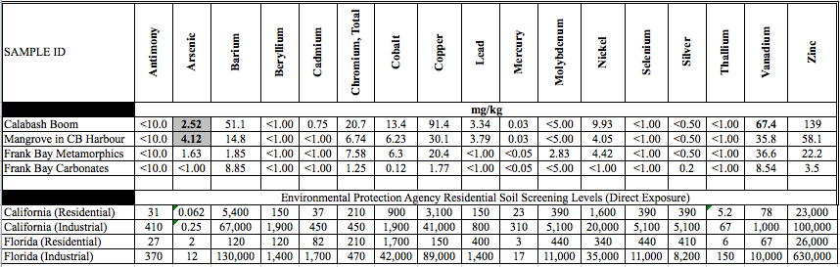
Kolupski, M., (2008) Unpublished Masters Thesis, University of San Diego, CA
CB stands for Coral Bay

The explanation given by Holmes and Miller (2004) for the high Pb and Zn in the Nassau cistern sample is erosional accumulation of weathered paint. However, past use leaded gasoline, which contained 0.5 – 0.8 g/l lead, discarded batteries household and industrial wasteburning (including paper products, discarded rubber, and painted woods) represent additional hazards (Nriagu, J. O., 1996).

Table 3. Selected trace metal concentrations for samples collected at various sites from Africa to the western Atlantic cisterns
(modified from Holmes and Miller, 2004)

In 1978, the Federal Government issued a ban on the use of lead in household paints. However, it is still possible to purchase outdoor paints with lead (600 mg/l), although these particular paints are being slowly phased out. Countries that are still producing significant amounts of paints with lead are India, Malaysia, and Singapore. The Bureau of Indian Standards has slated 1 g/l as the benchmark for acceptable levels of lead in paints, which is not only voluntary but also optional as a part of Ecomark labelling (Kumar, A and Gottesfeld, P., 2008). Therefore, a manufacturer is not bound by law to provide safe household paints, even if they pose serious health risks.
It is possible that the elevated Pb levels on Dixon Hill come from the painting of the lighthouse last summer (2007), however, there were no observable paint chips on the ground. A paint sample will be tested in the future. Other sources of Pb are short term or long term activities on other continents that may influence the composition of the dust coming from Africa. Around 1967, Algeria was at its peak in mining Pb and Zn. The Qued Amizour Project in northern Algeria was producing about 40,000 tons of material per year that was reduced to 31,000 tons per year (Barradas, S., 2007). It is possible that the Pb and Zn in the Nassau cistern came from this mining operation and not from paint, because paints generally do not have large amounts of zinc.
It is clear that the source of metals found throughout the Bahamas both on the surface and in the underground environment is from North Africa; however, we have shown that the concentration of the metals that are adsorbed onto the dust particles found on site, may have a more vagrant history as a result of the different geochemical environments that the dust may have been exposed to during its travels and in its current resting place. Many of these metals that arrive with the dust, including the iron-oxide dust itself is extremely important in supporting local vegetation and biology life, especially microbial life. With the purity of the local limestone and without the dust input, life on the island could be very different. More work needs to be done to identify the speciation of these metals to confirm whether they pose any environmental concerns and through additional research, we can acquire a database that informs us whether high levels of certain metals are of local toxic concern or not.

ACKNOWLEDGMENTS

The authors wish to acknowledge H. M. Pitt Labs Inc, owner of
EnviroMatrix Analytical Laboratory for metal analyses, without which this study would not have been possible. We also thank Megan Kolupski for the Virgin Island metal results; Schwabe thanks Dr. John Parkes for his support during her Ph.D. research. We also thank Dr. Donald T. Gerace, CEO, and Dr. Thomas Rothfus, Executive Director, of the Gerace Centre, San Salvador, Bahamas, for logistical and personal support; and Wings Trust for financial support.

REFERENCES

Ahmad, N., and Jones, R. L., 1969, Occurrence of aluminous lateritic soils (bauxites) in the Bahamas and Cayman Islands: Economic Geology, v. 64, p. 804-808.

Barradas, S., 2007, Qued AMizour zinc project Algeria: Mining Weekley.com <www.miningweekley.com/article.php?a_id=107997>

Buat-Menard, P., 1993, Global change in atmospheric metal cycles, in: W.T. Sturges and A. E. Hewitt (eds.), Global Atmospheric Chemical Change. Elsevier, Amsterdam, p. 271-311.

Birkeland, P. W., 1999, Soils and Geomorphology: New York, Oxford University Press,. Need the number of pages in the book here
Carew, J. L., and Mylroie, J. E., 1991, Some pitfalls in paleosol interpretation in carbonate sequence: Carbonates and Evaporates, v. 6, p. 69-74.

Chiapelo, I., Bergametti, G., Chatenet, B., Bousquest, P., Dulac, F., and Soares, E. S., 1997, Origins of African dust transported over the northeastern tropical Atlantic: Journal of Geophysical Research, 94, p. 14 (?more pages, or just one?)

Criado, C., and Dorta, P., 2003, An unusual blood rain over canary islands (Spain). The storm of January 1999: Journal of Arid Environments, v. 55, p. 765-783.

Ersek, V., Mylroie, J. E., Kirkland, B. L., Carew, J. L., 2006, Paleosols of the Bahamas and Northern Mariana Islands: Source areas for the insoluble residue and relation to paleoclimate, in R. L. Davis and D. W. Gamble, eds., Proceedings of the Twelfth Symposium on the Geology of the Bahamas and Other Carbonate Regions (2004):San Salvador, Bahamas, Gerace Research Centre, p. 24-31.

Evans, R. D., Jefferson, I. F., Kumar, R., O’Hara-Dhand, K., and Smalley, I. J., 2004, The nature and early history of airborne dust from North Africa; in particular the Lake Chad basin: Journal of African Earth Sciences, v. 39, p. 81-87.

Foos, A. M., 1991, Aluminus lateritic soils, Eleuthera, Bahamas: A modern analog to carbonate paleosols: Journal of Sedimentary Petrology, v. 61. p. 340-348.

Garrison, V. H., Foreman, W. T., Genualdi, S., Griffin, D. W., Kellogg, C. A., Majewski, M. S., Mohammed, A., Ramsubhag, A., Shinn, E. A., Simonich, S. L., and Smith, G. W., 2006, Saharan dust- a carrier of persistent organic pollutants, metals and microbes to the Caribbean?: International Journal of Tropical Biology, v. 54 (Suppl.3) p. 3-21.

Goudie, A. S, and Middleton, N. J., 2001, Saharan dust storms: nature and consequences: Earth-Science Reviews, v. 56, p.179–204.

Griffin, P. W., and Kellogg, C. A., 2004, Dust storms and their impact on ocean and human health: dust in Earth’s atmosphere: EcoHealth v. 1 p 284-295.

Guieu, C., Loye-Pilot, M. D., Ridame, C., and Thomas, C., 2002, Chemical characterization of the Saharan dust end-member: Some biogeochemical implications for the western Mediterranean Sea: Journal of Geophysical Research, v. 107, No. D15, p. 1-11.

Hamelin, B., Grousset, F. E., Biscaye, P. E., Zindler, A., and Prospero, J., 1989, Lead isotopes in trade wind aerosols at Barbados: the influence of European emissions over the North Atlantic: Journal of Geophysical Research, v. 94 (C11); p. 16, 243-250.

Harrison, J. B., and Anderson, C. B. W., 1919, Notes on the extraneous minerals in the coral-limestones of Barbados: Quarterly Journal of the Geological Society of London, v. 75, p. 158-172.

Hem, J. D., 1985, Study and interpretation of the chemical characteristics of natural water (3rd ed.): U.S. Geological Survey Water-Supply Paper 2254, 263 p.

Hingston, F. J., Posner, A. M., and Quirk, J. P., 1971, Competitive adsorption of negatively charged ligands on oxide surfaces: Discussions of the Faraday Society, v. 52, p. 334-342.

Hinkle, S. R., and Polette, D. J., 1999, Arsenic in ground water of the Willamette basin, Oregon: Water Resource Investigation Report 98-4205, US Geological Survey, p. 19-22

Holmes, C. W., and Miller, R., 2002, The atmospheric transport and deposition of arsenic and other metals in the southeastern United States [abs.]: Geological Society of America Abstracts with Programs, v. 34, no. 6, p. 295.

Holmes, C. W., and Miller, R., 2004, Atmospherically transported elements and deposition in the Southeastern United States: local or transoceanic?: Applied Geochemistry, v. 19, p. 1189-1200.

Kumar, A. and Gottesfeld, P, 2008, Lead content in household paints in India: Science of the total environment, v. 407 (1), p. 333-337.

Livesey, N. T., and Huang, P. M., 1981, Adsorption of arsenate by soils and its relation to selected chemical properties and anions: Soil Science, v. 131, p. 88-94.

Manning, B. A., and Goldberg, S., 1997, Adsorption and stability of arsenic (III) at the clay mineral-water interface: Environmental Science and Technology v. 31, p. 2005-2011.

McKenzie, R. M., 1980, The adsorption of lead and other heavy metals on oxides of
manganese and iron: Australian Journal of Soil Research, v. 18(1), p. 61 – 73.

Moulin, C., Lambert, C. E., Dulac, F., and Dayan, U., 1997, Control of atmospheric export of dust from North Africa by the North Atlantic oscillation: Nature v. 387 p. 691–694.

Masscheleyn, P. H., Delaune, R. D., and Patrick, W. H., Jr., 1991, Effect of redox potential and pH on arsenic speciation and solubility in a contaminated soil: Environmental Science and Technology, V. 25, p. 1414-1419.

Muhs, D. R., Bush, C. A., Stewart, K. C., Rowland, T. R., and Crittenden, R. C., 1990, Quaternary limestones of Caribbean and Western Atlantic islands: Quaternary Research, v. 33, p. 157-177.

Muhs, D. R., Budahn, J. R., Prospero, J. M., and Carey, S. N., 2007, Geochemical evidence for African dust inputs to soils of western Atlantic island: Barbados, the Bahamas, and Florida: Journal of Geophysical Research, v. 112, p. 1-26.

Nriagu, J. O, 1989, Natural sources of trace metals in the atmosphere: Nature, v.338, p. 47-49.

Nriagu, J. O., Blankson, M. L., and Ocran, K., 1996, Childhood lead poisoning in Africa: a growing public health problem: The Science of the Total Environment, v. 181, p. 93-100.

Perkins, S., 2001, Dust, the thermostat: Science News, Issue 160, p. 200–201.

Perry, K. D., Cahill,T. A., Eldred, R., Dutcher, D. D., 1997, Long-range transport of North African dust to the eastern United States: Journal of Geophysical Research (Atmospheres), v. 102, p.11, 225. (?What are these page numbers? Some error?)

Price, R. E., and Pichler, T., 2002, Oxidation of framboidal pyrite as a mobilization mechanism during aquifer storage and recovery in the upper Floridian aquifer, Southwest Florida: American Geophysical Union, Fall Meeting, abstract #H72D-0890.

Prospero, J. M., and Lamb, P. J., 2003, African droughts and dust transport to the Caribbean: climate change implications: Science, v. 302, p. 1024–1027.

Robertson, F. N., 1989, Arsenic in ground-water under oxidizing conditions, south-west United States: Environmental Geochemistry and health, v. 11, p. 171-186.

Schwabe, S. J., 1999, Biogeochemical investigation of caes within Bahamian carbonate platforms, [Ph.D. Dissertation]: University of Bristol, UK, 239 p.

Welch, A. H., Lico, M. S., and Hughes, J. L., 1988, Arsenic in ground water of the Western
United States: Ground Water, v. 26, p. 333–347.

Wright, K., 2005, Blown away: Discover Magazine, v. 26, no. 3, p. 32-37.

